FACULTY OF ENGINEERING, BUILT ENVIRONMENT AND INFORMATION TECHNOLOGY
FAKULTEIT INGENIEURSWESE, BOU-OMGEWING EN INLIGTINGTEGNOLOGIE



DEPARTMENT OF INFORMATICS
DEPARTEMENT INFORMATIKA

INFORMATICS / INFORMATIKA 354

Semester test (open book practical) / Semestertoets (oopboek prakties)

May 2015

Lecturers / Dosente  Dr N Croft  Moderator / Moderator:  Dr WS Leung (University of Johannesburg) | Time / Tyd: 180 min  Mark / Punt: 65

Instructions | Instruksies
- Answer all the questions  - This is an open book practical test, with no internet access.  - No communication with other students is allowed.  - Save regularly on the C drive. Do not use the H drive.  - Please zip and upload all projects/documents on clickUP after the test. Name the zip file: s1234567_Initials_Surname, using your own information. | - Beantwoord al die vrae.  - Hierdie is ’n oopboek praktiese toets, met geen internet toegang nie.  - Geen kommunikasie met ander studente word toegelaat nie.  - Maak seker dat U gereeld “save” op die C skyf. Moenie die H skyf gebruik nie.  - Nadat die toets voltooi is, zip asseblief die programme/dokumente en laai die op na clickUP. Benoem die zip file: s1234567_Voorletters_Van deur jou eie inligting te gebruik.

NOTE: Section A and C must be answered in a new blank word document clearly showing the question number and your answer. Name the word document Section A and Section C and upload it as part of zip file submission.

Section A: Multiple choice questions [17]

- PHP is a language primarily used in web development. HTML and CSS are executed? [1]
A ⃝ server side
B ⃝ client side
C ⃝ in the controller
D ⃝ all of the above

- The server responsible for responding to http requests is known as a? [1]
A ⃝ standalone server
B ⃝ web server
C ⃝ cloud instance
D ⃝ none of the above

- _______ is an example of a web server? [1]
A ⃝ apache
B ⃝ iis
C ⃝ nginx
D ⃝ none of the above
E ⃝ all of the above

- A stored procedure returns? [1]
A ⃝ a single value
B ⃝ tabular data
C ⃝ no value
D ⃝ all of the above

- The code snippet below is an example of? [1]
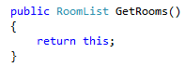
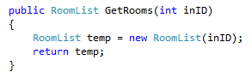
A ⃝ overloading
B ⃝ overriding
C ⃝ polymorphism
D ⃝ an abstract method

- Complete line [35] of the PHP code snippet [1]
1 <?php
2 $time = microtime();
3 $time = explode(' ', $time);
4 $time = $time[1] + $time[0];
5 $start = $time;
6 ?>

30 <?php
31 $time = microtime();
32 $time = explode(' ', $time);
33 $time = $time[1] + $time[0];
34 $finish = $time;
35 ________________________________________
36 echo 'Page generated in '.$total_time.' seconds.';
?>

[Answer] $total_time = $finish - $start 1 mark for $finish - $start

- What is the advantage of having such a code snippet in your PHP script above? [1]
[Answer] scripts load slow, measure delays such as writing/reading to/from files or MySQL database

- Discuss the advantages of including stored procedures as part of your database design. [2]
[Answer]Any two of better performance, higher productivity, ease of use (write once use many), and increased scalability, better memory management etc. Use discretion when marking.

- Model–view–controller (MVC) is a software architectural pattern for implementing user interfaces. It divides a given software application into three interconnected parts, so as to separate internal representations of information from the ways that information is presented to or accepted from the user. Discuss what each of the components (model, view and controller) might consist of. [3]
[Answer] The central component, the model, consists of application data, business rules, logic and functions. A view can be any output representation of information, such as a chart or a diagram. Multiple views of the same information are possible, such as a bar chart for management and a tabular view for accountants. The third part, the controller, accepts input and converts it to commands for the model or view

- When developing Windows mobile phone apps, we are required to download the Windows Phone SDK 7.1 which included the windows phone emulator. What is a SDK and why is it needed for mobile development? [1]
[Answer] Software development kit [1/2 mark]. It contains the mobile framework required to develop and package source code for a specific mobile operating system [1/2 mark].

- When running the Windows mobile phone emulator in the orange labs on campus, our emulators crashed. The reason why this happened is because? [2]
[Answer] the emulator runs as a virtual machine [1 mark]. The computers in the labs themselves run as virtual machines causing the crash as a virtual machine cannot run inside a virtual machine [1 mark].
- Name and describe one major difference between a MongoDB database and a MS SQL Server database. [2]
[Answer] document orientated vs relational [1] the other [1] for a description of each

Section B: Multi-Tier Programming [33]
Create a MS SQL Server database called zoodb from the zoodb.sql script provided. Do NOT change the database. The database diagram is shown below.

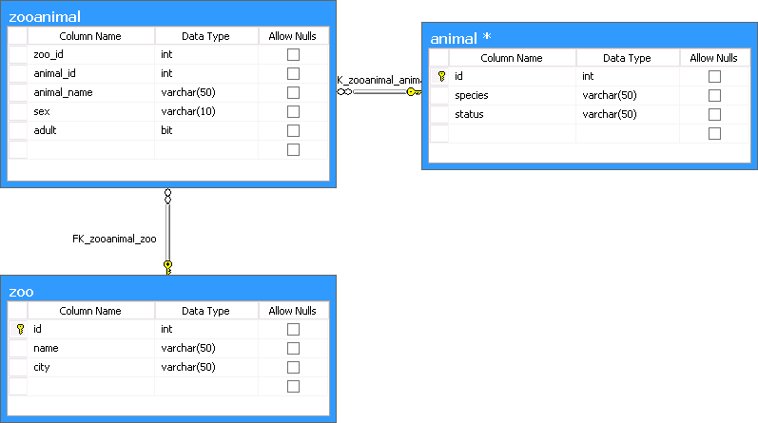

- Write stored procedures for inserting, deleting and updating data from each of the database tables (zoo, animal, zooanimal).[9] 3 marks each for stored procedures for zoo, animal, zooanimal. Deduct 1 mark for incorrect parameters, incorrect SQL query. Use your discretion here.

create procedure sp_animal_Update
(
@id INT,
@species varchar(50),
@status varchar(50)
)
as
UPDATE animal
SET
[status] = @status,
species = @species
WHERE id = @id
Go
create procedure sp_animal_Insert
(
@species varchar(50),
@status varchar(50),
@identity INT OUT
)
as
INSERT INTO animal values(@species, @status)
SET @identity = SCOPE_IDENTITY()
Go

create procedure sp_zooanimal_Update
(
@zoo_id INT,
@animal_id INT,
@animal_name varchar(50),
@sex varchar(10),
@adult bit
)
as
UPDATE zooanimal
SET
animal_name = @animal_name,
sex = @sex,
adult = @adult
WHERE zoo_id = @zoo_id and animal_id = @animal_id
Go

create procedure sp_zooanimal_Insert
(
@zoo_id INT,
@animal_id INT,
@animal_name varchar(50),
@sex varchar(10),
@adult bit,
@identity INT OUT
)
as
INSERT INTO zooanimal values(@zoo_id, @animal_id, @animal_name, @sex, @adult)
SET @identity = SCOPE_IDENTITY()
Go

create procedure sp_zoo_Update
(
@id INT,
@name varchar(50),
@city varchar(50)
)
as
UPDATE zoo
SET
name = @name,
city = @city
WHERE id = @id
Go

create procedure sp_zoo_Insert
(
@name varchar(50),
@city varchar(50),
@identity INT OUT
)
as
INSERT INTO zoo values(@name, @city)
SET @identity = SCOPE_IDENTITY()
Go

create procedure sp_zoo_Delete
(
@id INT
)
as
Delete zoo
WHERE id = @id
Go

create procedure sp_animal_Delete
(
@id INT
)
as
Delete animal
WHERE id = @id
Go

create procedure sp_zooanimal_Delete
(
@zoo_id INT,
@animal_id INT
)
as
Delete zooanimal
WHERE zoo_id = @zoo_id and animal_id = @animal_id
Go
- Complete the business tier program called zooBusinessTier provided. Download and extract zooBusinessTier.zip, run the .sln file and complete the incomplete methods in the classes zoo.cs, animal.cs and zooanimal.cs and the bindinglist classes [11].

See attached for possible solution. Marks awarded as follows:
Zoo.cs [1 marks total]
1/2 mark correct constructor
1/2 mark correct getters and setters

ZooAnimal.cs [1 marks total]
1/2 mark correct constructor
1/2 mark correct getters and setters

Animal.cs [2 marks total]
2 marks for correct isEndangered [1 for for loop, 1 for status checked]
zoodbDataSet ds = new zoodbDataSet();
foreach (zoodbDataSet.animalRow row in ds.animal.Rows)
{
if (animalid == row.id)
{
if (row.status.Contains("endangered"))
{
return true;
}
}
}
return false;

AnimalList.cs [2 marks total]
1/2 mark CRUD methods
1/2 mark correct constructors
1 marks for correct save

zooList.cs [2 marks total]
1/2 mark CRUD methods
1/2 mark correct constructors
1 marks for correct save

zooAnimalList.cs [2 marks total]
1/2 mark CRUD methods
1/2 mark correct constructors
1 marks for correct save

- Once compiled the zooBusinessTier.dll file is created. What is a dll file and how is it used in other projects? [2]
[Answer] dynamic link library, its used as an external reference in another project. The dll will have to be included and deployed along with a project which is using it.

- If we are presented with two or more .dll files with the same name, how might we different their uses in our project to reference the correct .dll file? [1]
[Answer] Namespace

- We can choose to compile in our Visual Studio source code in either debug mode or in release mode. Explain the difference between the two? [2]
[Answer] if the student answers the one is for debug and the other is for release, no marks.
The main difference is when compiled in debug mode, pdb files are also created which allow debugging (so you can step through the code when it’s running). In Debug Mode your program has debug information inside of it (source code, variable names and other similar stuff like that). In Release Mode your program lacks of debug information makes it smaller and probably performs better due to its smaller footprint.
- Create a complementing presentation tier containing a form for each class list in the business tier zooBusinessTier that in turn contains a DataGridView that allows the user to perform CRUD operations on the data. The DataGridView for zoo must contain a comboBox for the zooid field that displays the zooname. This DataGridView must also have a combo box for animalid which must display the species. NOTE: there must be no DataSet in the PresentationTier. [8]
1 mark added reference to businessTier
6 marks CRUD + dataviews [ 2 marks each for zoolist, animallist, zooanimallist] eg Save
private void zooanimallistBindingNavigatorSaveItem_Click(object sender, EventArgs e)
{
zooanimallistDataGridView.EndEdit();
list.Save();
}

1 mark correct use of combo box
Section C: Mobile Web Development [5]
As a developer you are tasked with the design of a digital strategy to develop a mobile site and a web site. You decide on a RWD approach making use of a DDR.
- What is the purpose of a DDR and how is it used? [2]
Device detection repository, to lookup a requesting device and find its capabilities
- Discuss what a RWD approach entails? [2]
Responsive web design, to render back a response to a requesting browser based on its unique properties/capabilities. Response on the fly
- If we are not to make use of a DDR, what other technology may be used to accommodate for mobile device screen size restrictions. [1]
CSS3 media queries for screen resolution styling
Section D: LINQ and MongoDB [10]

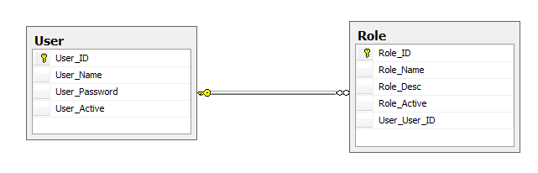
Use the diagram below to complete the questions that follow:
- Translate the following SQL statement to a LINQ or lambda statement (*Hint Lambda statements can be used within a LINQ statement): [5]
“SELECT * FROM User
INNER JOIN Role ON User.User_ID=Role.User_User_ID
WHERE User.User_ID=’5’ OR Role.Role_Desc=’admin’;”

“db is previously defined”
var query =
from b in db.User.Include(o => o.Role)
where b.Role.Role_Desc == ‘admin’ && b.User_ID == 5
select b;

- Write down the MongoDB JSON document structure that can represent the above relational database structure. (*Hint, in this instance, a MongoDB collection is represented by a table in a relational database). [5]

{
User_ID: "1",
User_Name: “Bob”,
User_Password “123RDXDS”,
User_Active: true,
{
User_User_ID “1”
Role_Name: "admin",
Role_Desc: “Full Access”,
Role_ID: "1"
Role_Active: “true”
}
{
User_User_ID “1”
Role_Name: "clerk",
Role_Desc: “View Access”,
Role_ID: "2"
Role_Active: “false”
}
}

